ITS 452

Final Project Presentation and Report

Fadi Haddad

Timothy Yu

**The Project Report**

1) A website named ASL For Kids is designed for any age who are interested in learning ASL in fun way. It will include stories to watch which has ASL Story 1 to 10 and A to Z.

2) 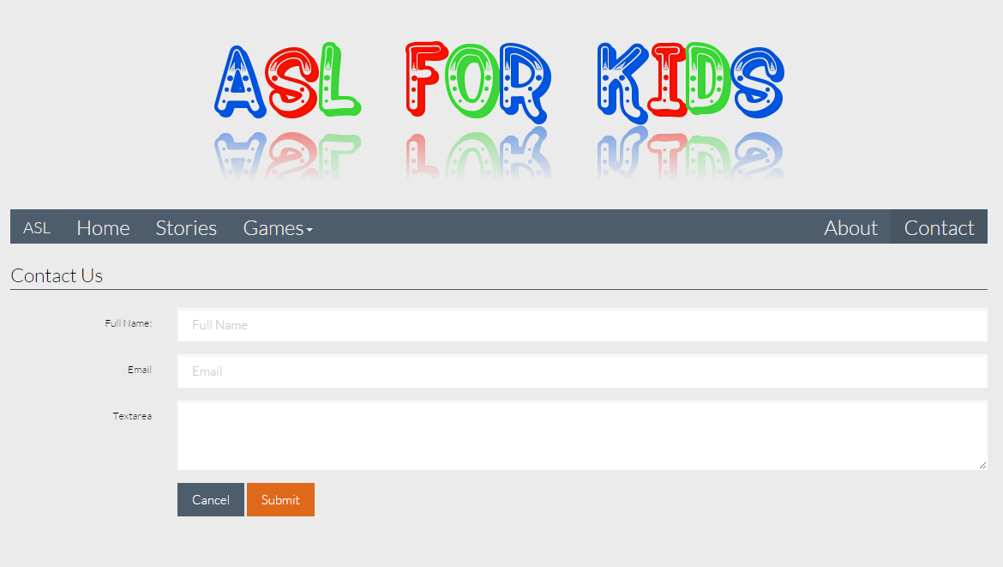

3) We just started on the templates, finished with Home and About and Contact. As of 12/03/14, we are working on Stories and Games.

**The Project Presentation**

On December 12

**Website Development Expectation**

1) JQuery **–** Check

2) No hard coding

3) Database design completed. One table for username and password, second table for scores.

4) Fadi on Memory Cards page, Tim on Mix and Match. The rest of website worked as equally.

5) JavaScript (Games)